Evaluation: Random Forest
Accuracy: 0.9652
Precision: 0.965237671594467
Recall: 0.9652
F1 Score: 0.9651584115090563
Jaccard Index: 0.9329191326671995
Matthews CorrCoef: 0.9565300355146801
Cohen’s Kappa: 0.9565
Specificity: 0.9913000000000001
AUC: 0.9979153000000001
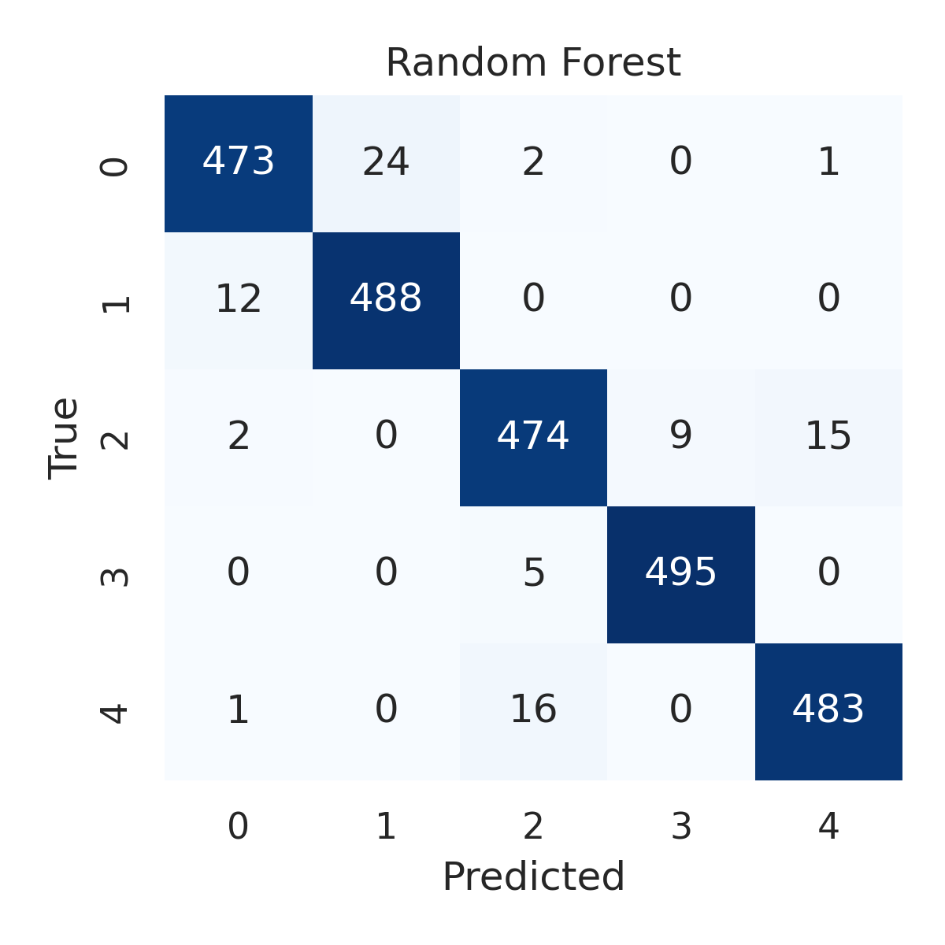

Combined ROC Curves
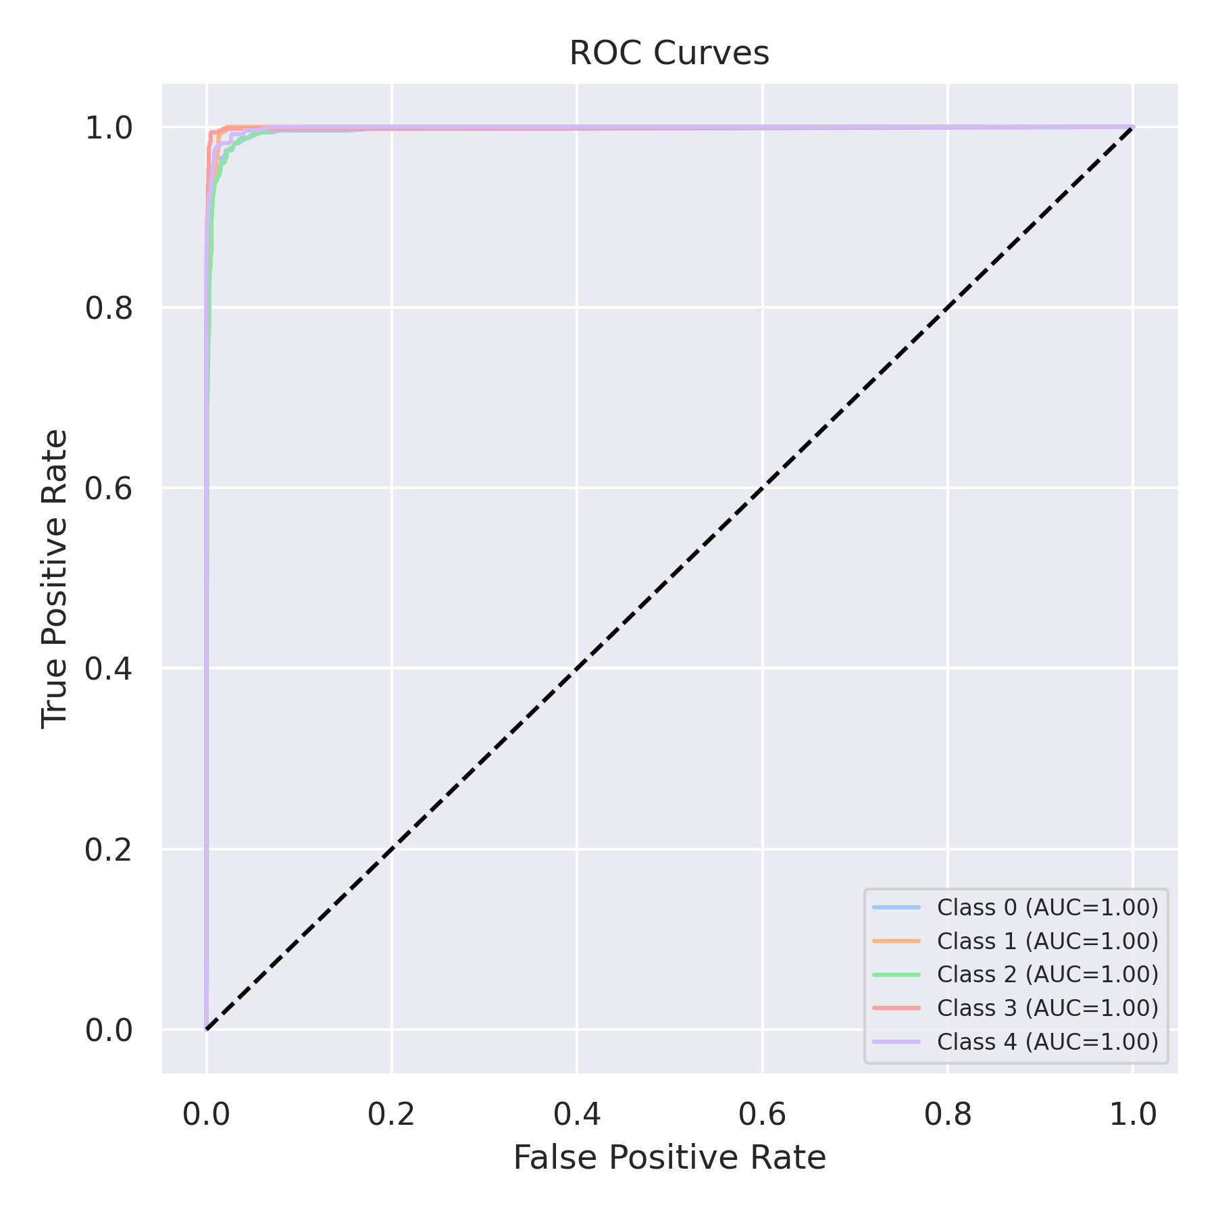

Evaluation: K-Nearest Neighbors
Accuracy: 0.8928
Precision: 0.8957967119235245
Recall: 0.8928
F1 Score: 0.8919704846051776
Jaccard Index: 0.8067843190333329
Matthews CorrCoef: 0.8670897495184131
Cohen’s Kappa: 0.866
Specificity: 0.9732
AUC: 0.9801826
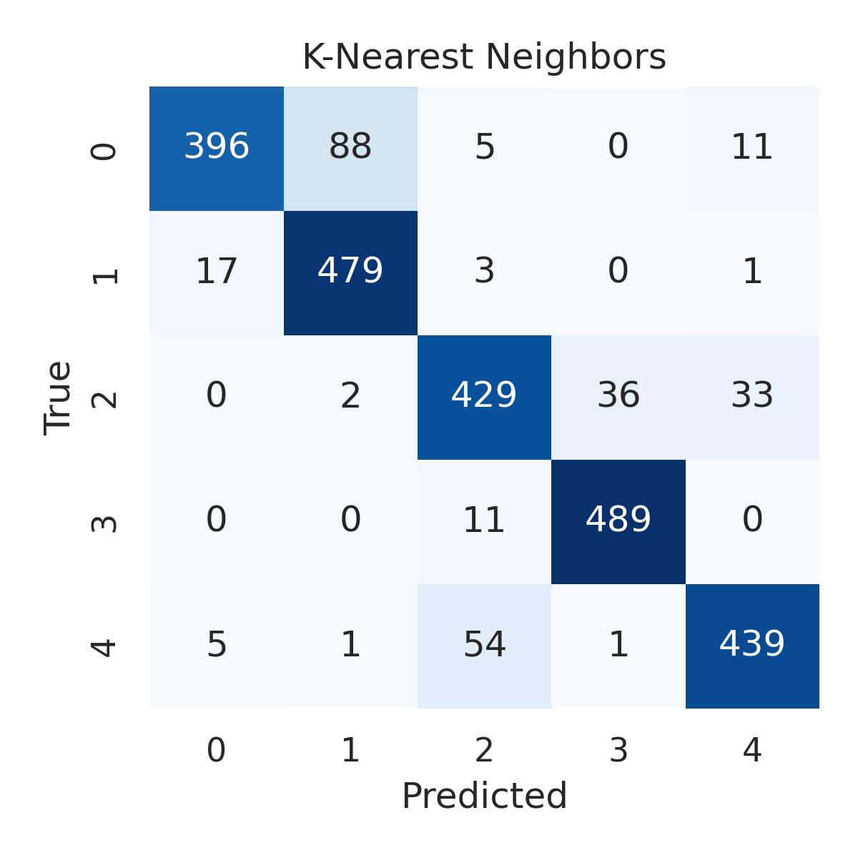

Combined ROC Curves
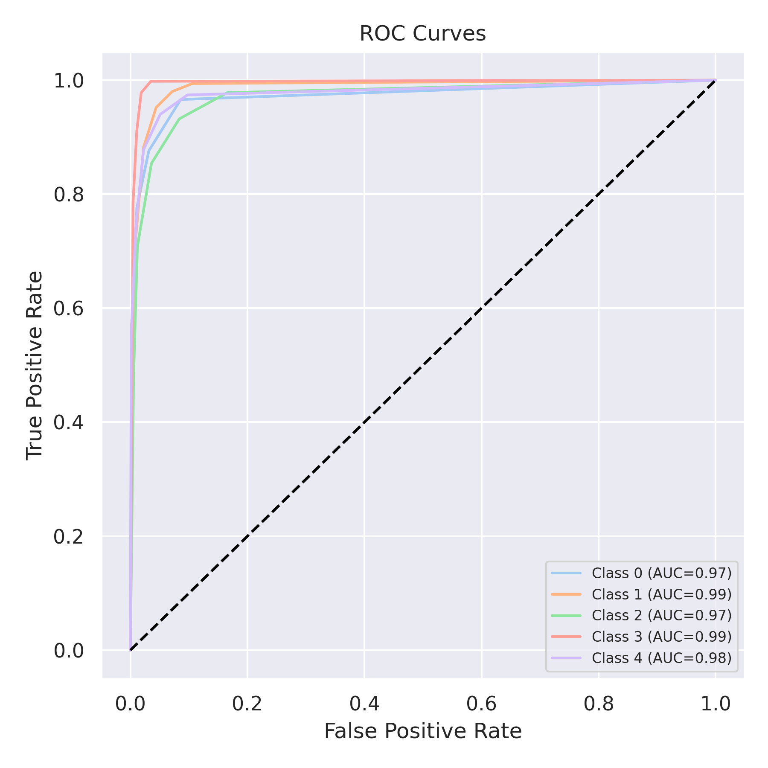

Evaluation: Decision Tree
Accuracy: 0.9548
Precision: 0.9549368337661787
Recall: 0.9548
F1 Score: 0.9548407930651256
Jaccard Index: 0.9140293981460127
Matthews CorrCoef: 0.943513775401682
Cohen’s Kappa: 0.9435
Specificity: 0.9887
AUC: 0.9717500000000001
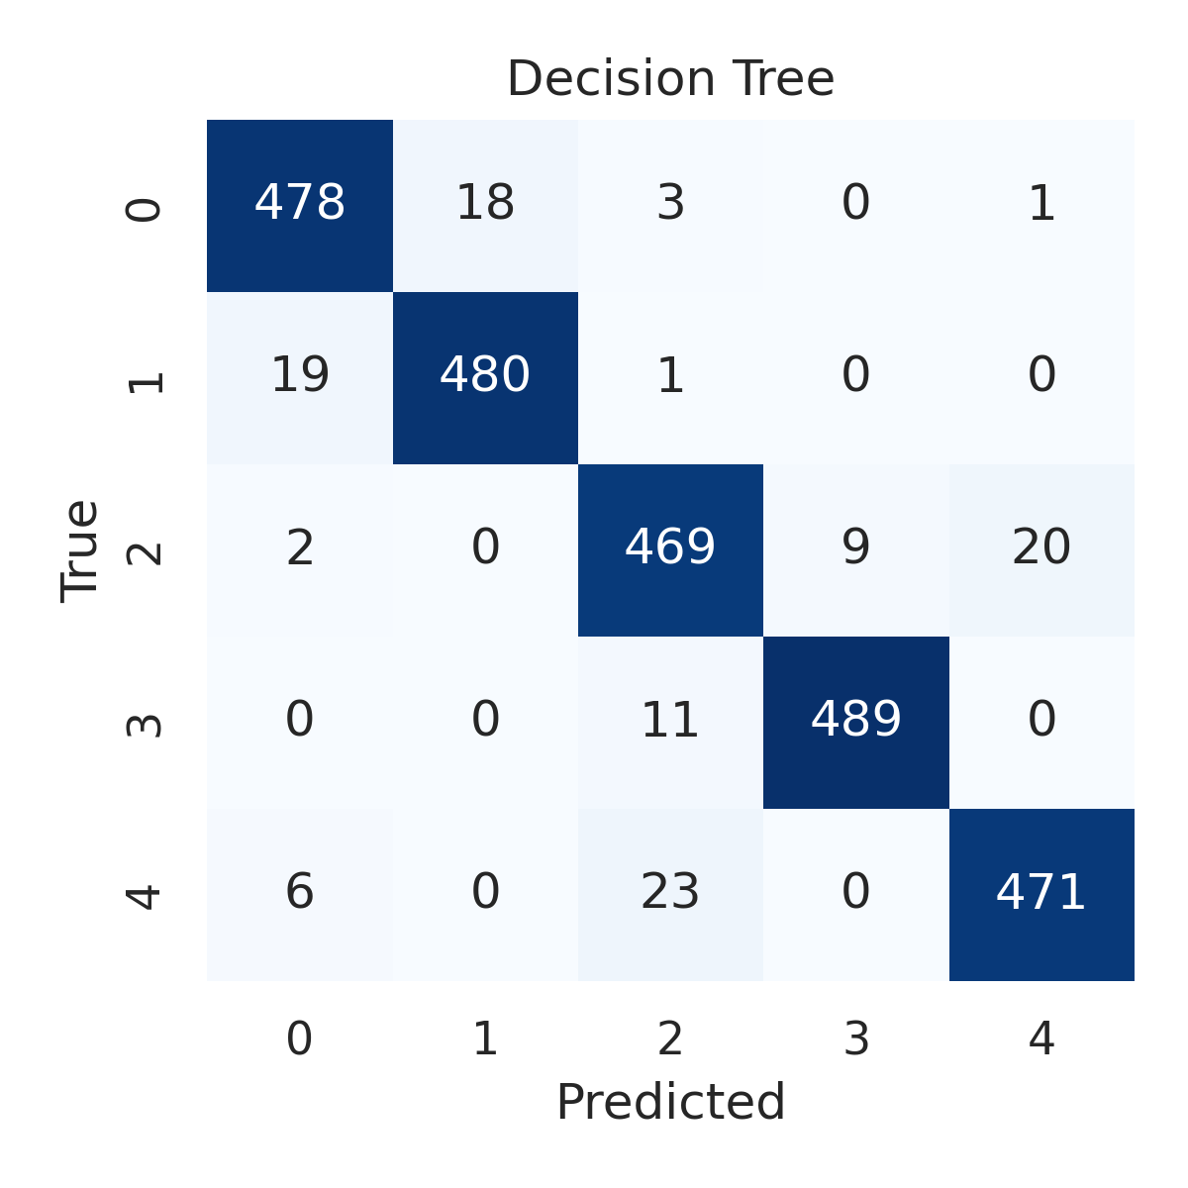

Combined ROC Curves
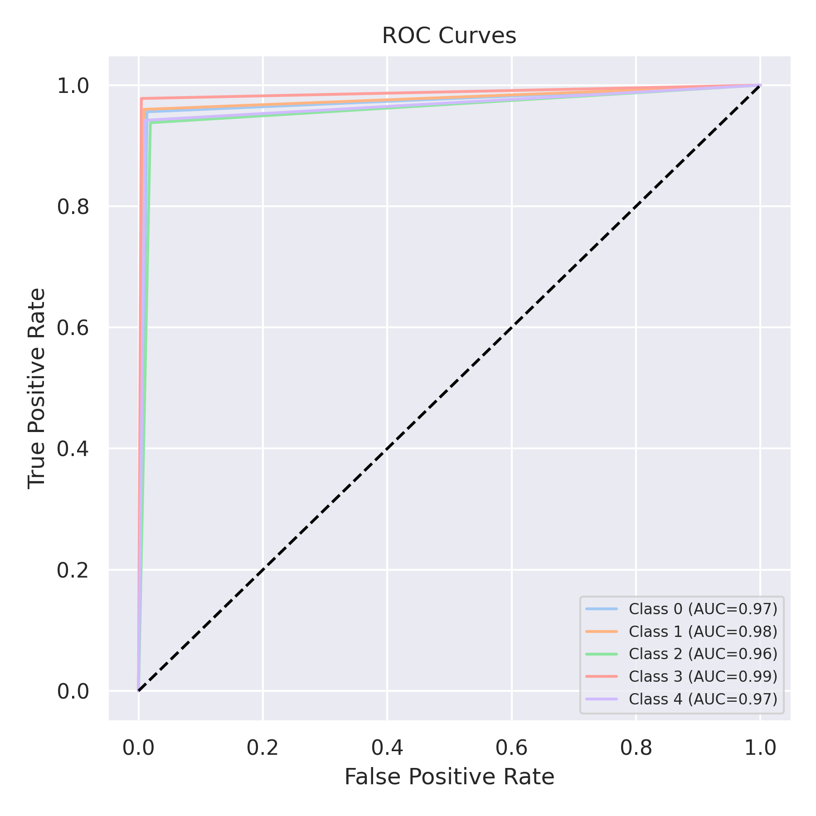

Evaluation: Extra Trees
Accuracy: 0.9672
Precision: 0.9671986898884332
Recall: 0.9672
F1 Score: 0.9671674141492087
Jaccard Index: 0.9366888443458669
Matthews CorrCoef: 0.9590157279869096
Cohen’s Kappa: 0.959
Specificity: 0.9918000000000001
AUC: 0.9987270999999998
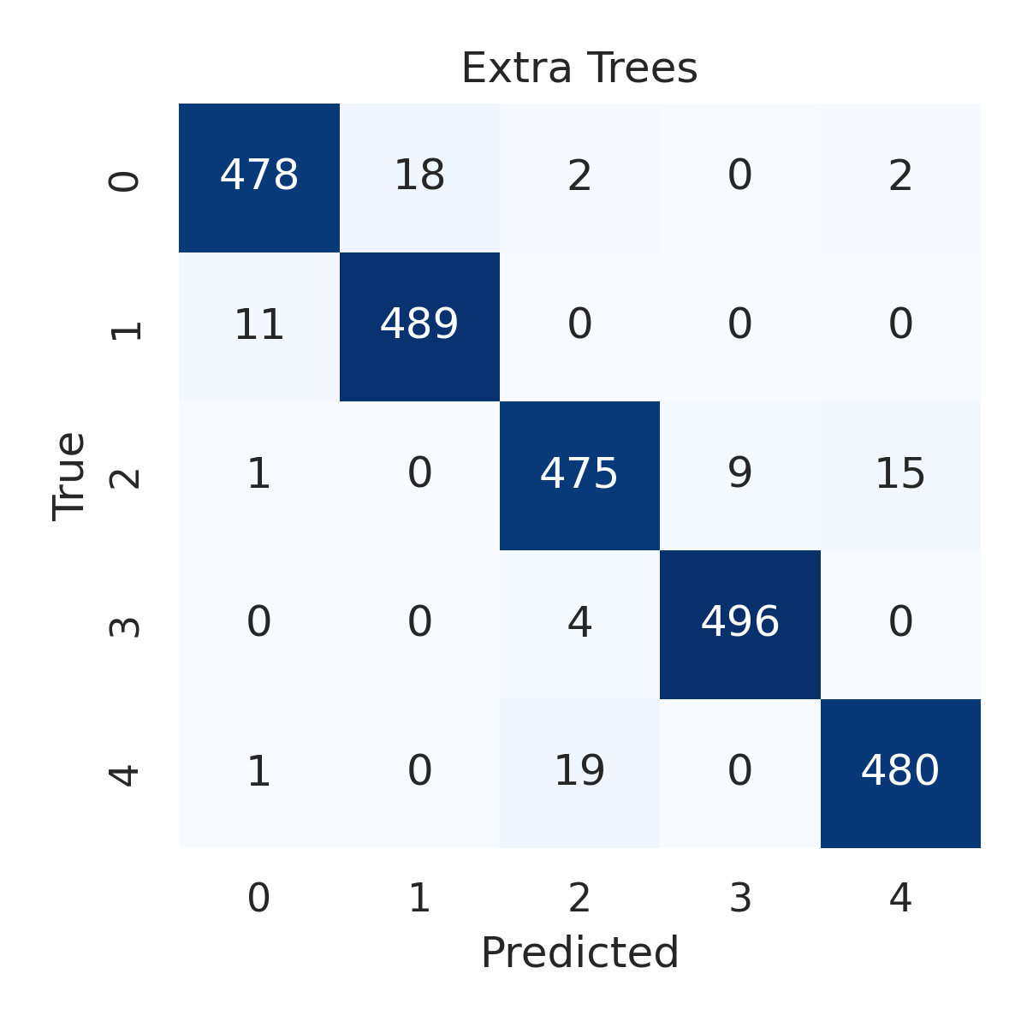

Combined ROC Curves
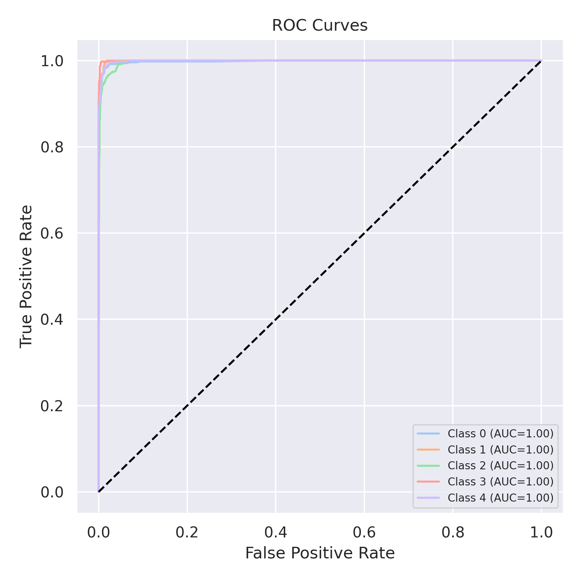

Evaluation: Bagging Classifier
Accuracy: 0.9744
Precision: 0.9747198211436995
Recall: 0.9744
F1 Score: 0.974418951666229
Jaccard Index: 0.9502505509269875
Matthews CorrCoef: 0.968070090811954
Cohen’s Kappa: 0.968
Specificity: 0.9936
AUC: 0.9944703
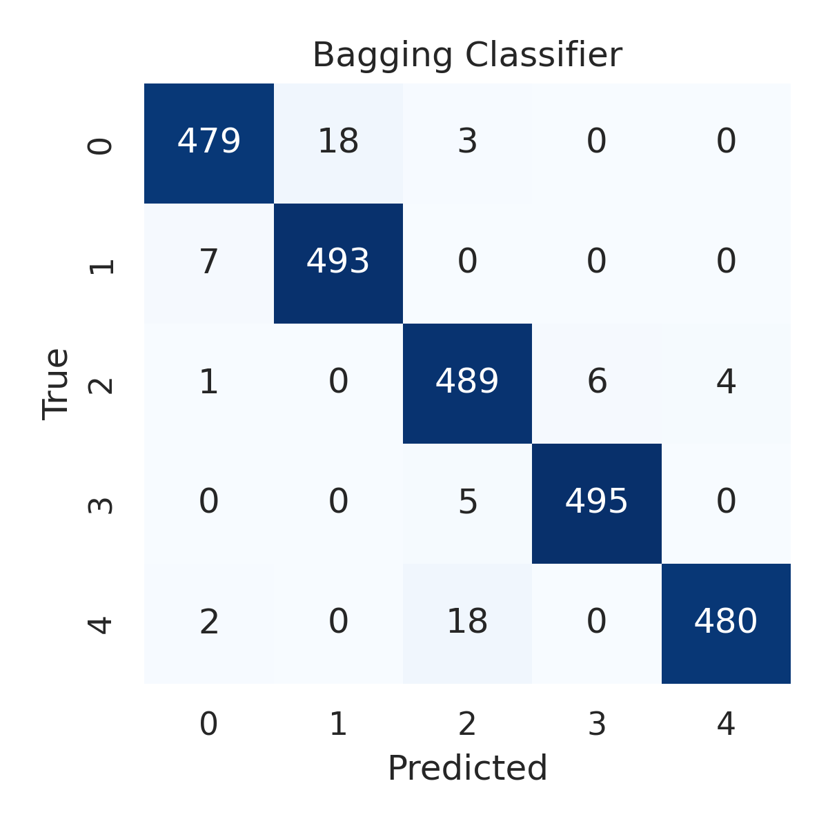

Combined ROC Curves
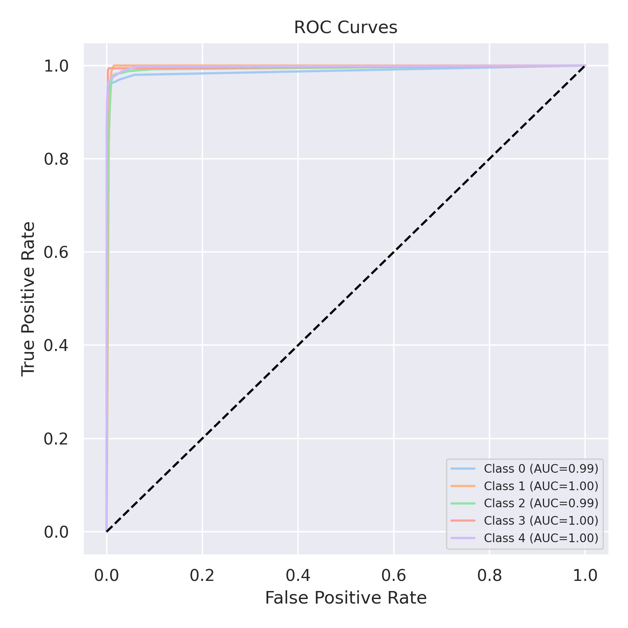

Evaluation: XGBoost
Accuracy: 0.9812
Precision: 0.9813690187774348
Recall: 0.9812
F1 Score: 0.9811890002040238
Jaccard Index: 0.9631543644426489
Matthews CorrCoef: 0.976547656688498
Cohen’s Kappa: 0.9765
Specificity: 0.9953
AUC: 0.9992286
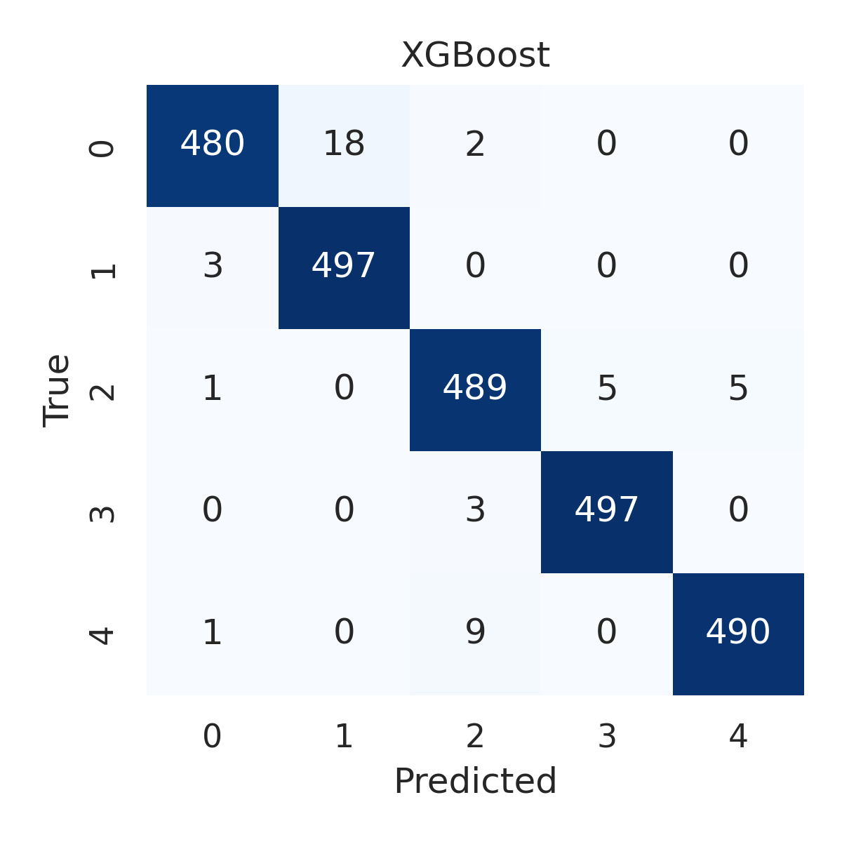

Combined ROC Curves
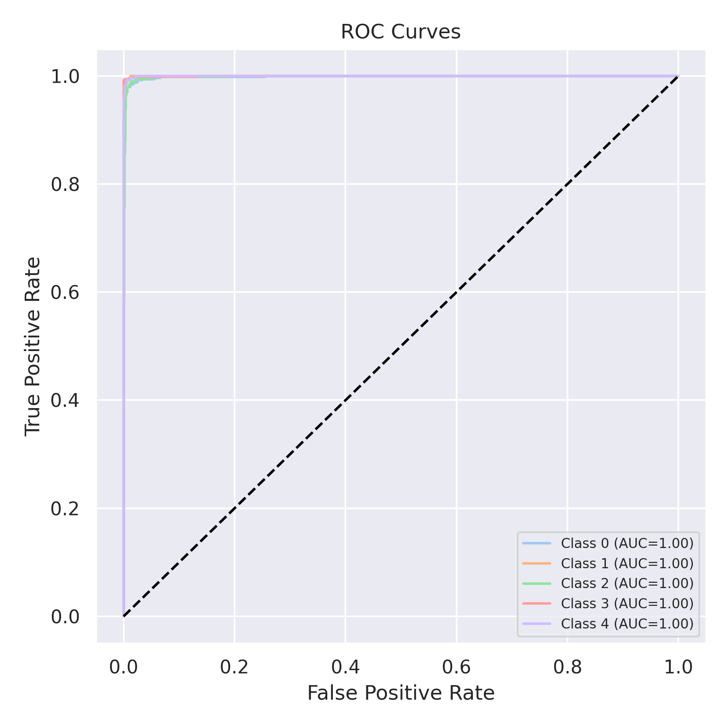

Evaluation: LightGBM
Accuracy: 0.9832
Precision: 0.9833072412347832
Recall: 0.9832
F1 Score: 0.9831949708843766
Jaccard Index: 0.9670103263702529
Matthews CorrCoef: 0.9790291755041515
Cohen’s Kappa: 0.979
Specificity: 0.9958
AUC: 0.9993297999999999
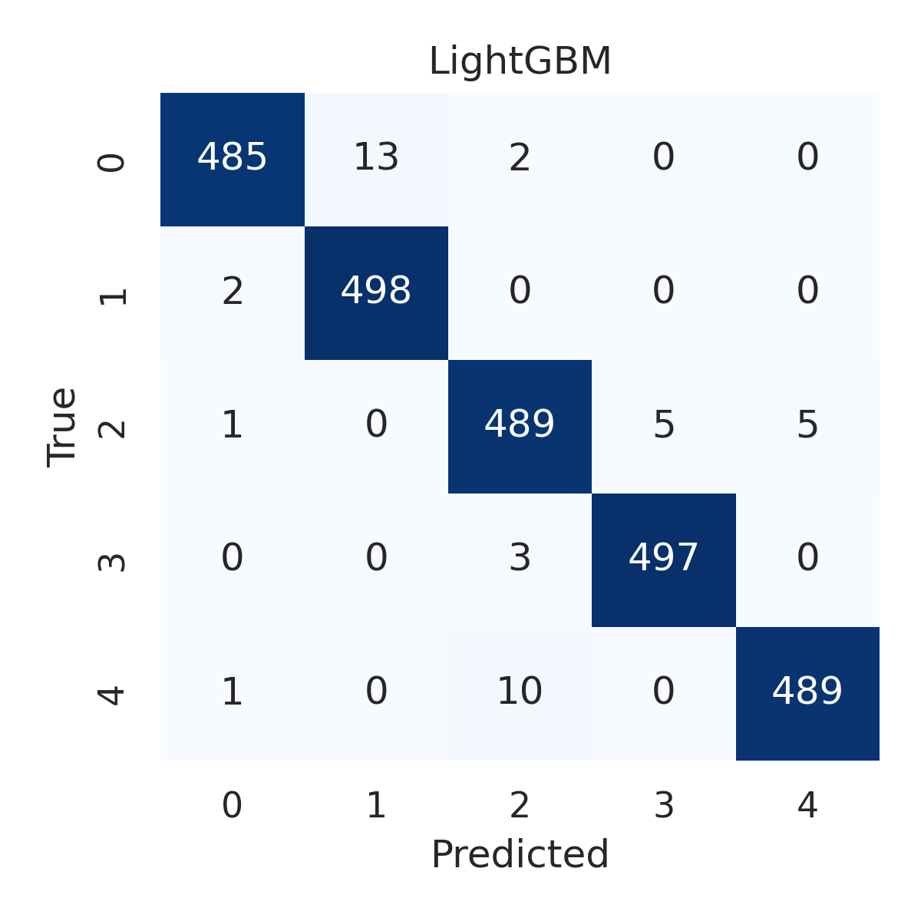

Combined ROC Curves
